**National University of Computer & Emerging Sciences**

**Karachi Campus**



**ROTANIKA 1.0**

**Project Report**

**Data Structures**

**Section: A**

**Group Members:**

**19K-1322 Obaid Ullah Shahab Ghouri**

**19K-0221 Syed Basit Khursheed**

Introduction

Rotanika 2.0 is a computer game having a mode: ‘Read My Mind ‘. It attempts to determine what real-life Pakistani actors user is thinking of , by asking a series of questions.

Main Features

* Data Structures :

This game uses following Data structures :

1. **N-array Tree:**

The Tree is used as a question tree. Each node is allotted a key. The program traverse through the tree, and compares each key to file, and asks that particular question.

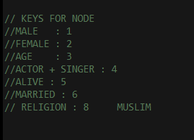

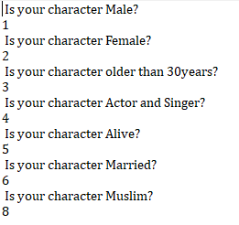

1. **QUEUE :**

The question key from the tree is first stored in the queue, which then pops out each key, and compares with keys in the file.

( A sample code of Traverse of Tree from the program, which pushes it’s each node to queue )

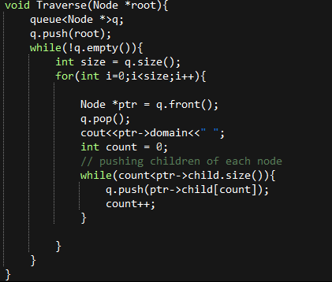

FRONT

**5**

**6**

**8**

**3**

**4**

**1**

1. **Linked List :**

In this Project singly Linked List is used to store the answers of each question by the user.

Which is later is used to compare the data of each actor. Once all the values are match with the data of an actor the program Gives a successful match message.



**Declaring The Linked List object**

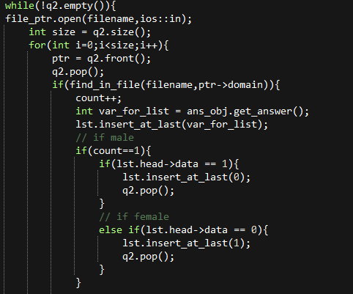

**Getting the answer of each question and storing it in the SLL.**

* FILING :

For the database, .txt files are used to store questions, details of male and female actors.

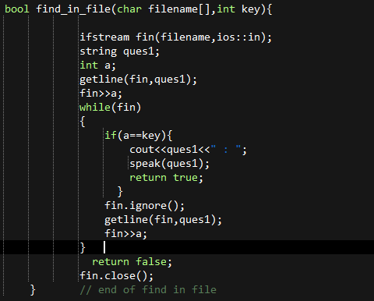

**This function takes a filename and a key, as parameters, and find the data from the required file.**

**For example : Questions is to be fetched from questions.txt, the function first will read the question then it’s key, then compare the question key, with the required key. If it is matched, it return true, else it returns false**

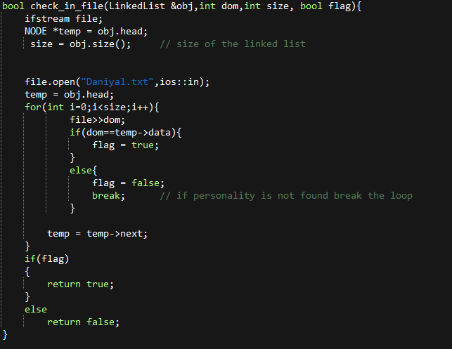

**This function is for comparing with the answer key from the required character file**

Application :

“ROTANIKA” is just a small guessing game for entertainment. While using the program, the system speaks each question for the user.

This project implements N-ary tree, queues and LL. There are many real-life examples of each DS.

**TREES :**

**\***XML documents can be stored in RAM using a DOM tree, that is a N-ary tree containing XML elements, nodes, etc. as children.

* Backtrack algorithm to find solutions is implemented using trees.

**QUEUES :**

**\***In real life scenario, Call Center phone systems use Queues to hold people calling them in order, until a service representative is free.

*A real-world example of the queue can be a single-lane one-way road, where the vehicle enters first, exits first.

**LINKED-LIST :**

**\*** Previous and next images are linked, hence can be accessed by the next and previous button.

* Songs in the music player are linked to the previous and next songs. you can play songs either from starting or ending of the list.

OUTPUTS :

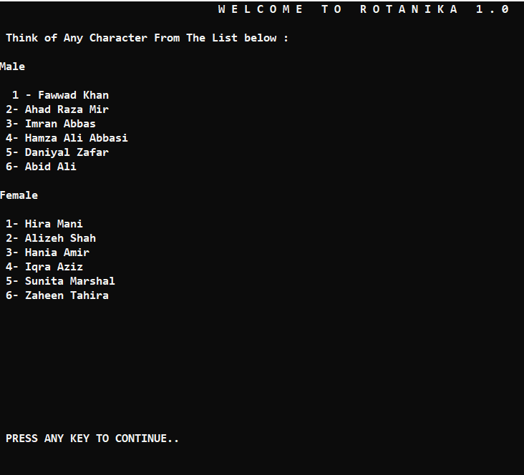

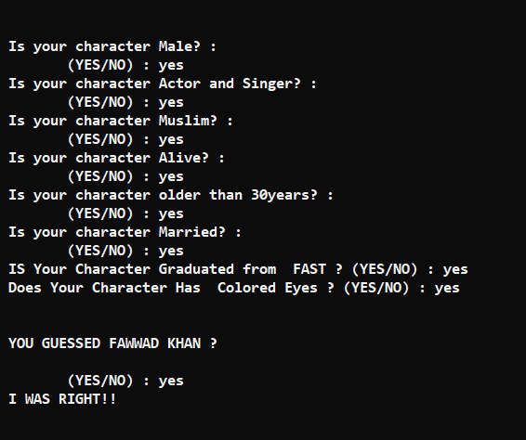

**xxxx-THE END-xxxx**